**CSC 3101 - FALL 2016**

**Lab Assignment 8**

Please read the requirements carefully. Any missing point will result in a grade reduction. This assignment has to be submitted to your **blackboard in class** in this **Word file**. Hard copy is **not accepted**.

**Question1:** **(50 pts.)**

Translate the following algorithm into assembly language. Input X from keyboard using Trap #15. Show both outcomes where X is greater than 12 or otherwise. (Please attach your code and screenshots in this file for submission.)

*if X > 12*

*X = 2*X+4*

*else*

*X = X - 13*

*display X*

**Problem was changed to X = X+1**

**Code Below:**

*-----------------------------------------------------------

* Title : Lab 8

* Written by : Caleb Latimer

* Date : 11/2/2016

* Description: Conditionals(part 1)

*-----------------------------------------------------------

ORG $1000

START: ; first instruction of program

* Put program code here

MOVE.B #14,D0 ;Display the starting message

LEA prompt,A1

TRAP #15

MOVE.B #4,D0 ;Load X (stored in D1.L)

TRAP #15

CMP #12,D1 ;compare X to 12

BGT if ;BGT: greater than

;if X>12, jump to branch labeled if

;else, do nothing

BLE else ;BLE: less than or equal to

;if X<=12, jump to branch else

;else, do nothing

else

ADD #1,D1

BRA end ;jump to branch end

if

MULS #2,D1

ADD #4,D1

end

MOVE.B #14,D0 ;Display the ending message

LEA result,A1

TRAP #15

MOVE.L #3,D0

TRAP #15

SIMHALT ; halt simulator

* Put variables and constants here

prompt DC.B 'Enter a number for X: ',0

result DC.B 'The resulting X is: ',0

END START ; last line of source

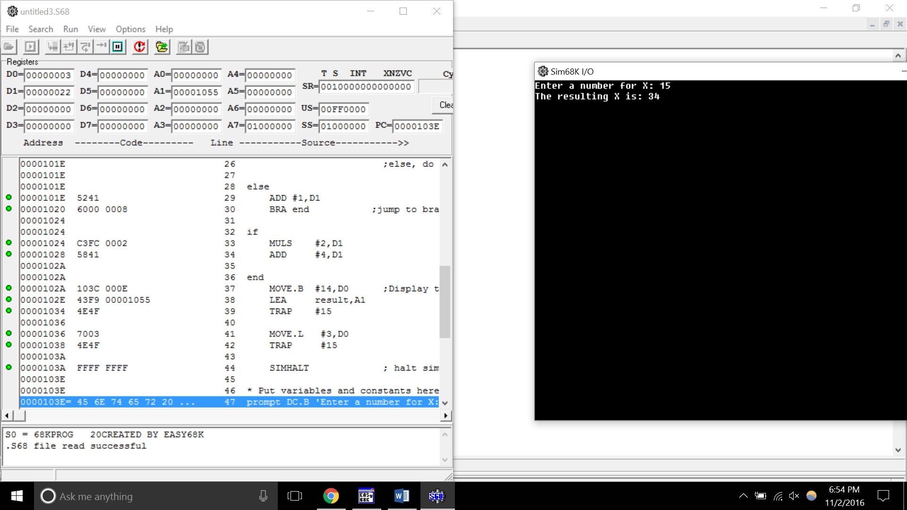

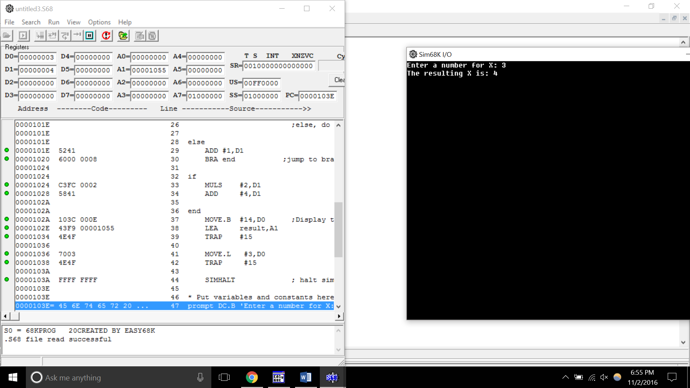

**Question2:** **(50 pts.)**

Translate the following code into assembly language. Please attach your code and screenshots in this file for submission.

*X = 0;*

*Y = 1;*

*while (X <= 10) {*

*if (X%2 == 0)*

*Y = Y * X;*

*else*

*Y++;*

*X++;*

*}*

*printf (“Y is: %d\n”, Y)*

*-----------------------------------------------------------

* Title : Caleb Latimer

* Written by : Lab 8

* Date : 11/2/2016

* Description: Lab 8(loop)

*-----------------------------------------------------------

ORG $1000

START: ; first instruction of program

* Put program code here

MOVE.B #0,D1 ;X = D1

MOVE.B #1,D2 ; Y = D2

while

CMP #10,D1 ; compare X with 10

BLE if ; if x <= 10 do if

BGT end ; if not exit while() do end

if

MOVE.L D1,D3

DIVU #2,D3

SWAP D3

CMP #0,D3

BEQ executeif

BNE else

executeif

MULS D1,D2

ADD #1,D1

BRA while

else

ADD #1,D2

ADD #1,D1

BRA while

end

MOVE.B #14,D0 ;Display the ending message

LEA result,A1

TRAP #15

MOVE.L D2,D1

MOVE.L #3,D0

TRAP #15

SIMHALT ; halt simulator

* Put variables and constants here

result DC.B 'The result is: ',0

END START ; last line of source

